**Assignment 4**

* Add validations for the form
* Use regex to validate phone number, email and zip code.
* Validation should show a red color text along with each field and disappear on correcting particular field
* Create a single select list box which has 5 elements
* Write an onChange event for the created list which adds checkbox that changes dynamically for each selection

**Example**:

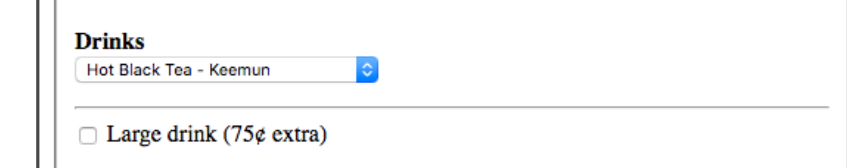

* If the checkbox is enabled, add a text field and make it mandatory and on disabling checkbox, text field should disappear
* On submit, create a html table which takes all the data from the previously submitted form and display results